Accounting for Leases
Guidance Statement
Guidance outlines the accounting procedures for the recording and reporting of leases and for the recording of installment purchase contracts.
Note: FASB 13 will be replaced by GASB 87 effective 7/1/2020 and reflected in Financial Statements for 6/30/2021.
The change will establish a single model for lease accounting. Content in this page is in the process for being
updated.

Definitions
Capital Lease: All leases meeting the capital lease criteria must be capitalized.
Operating Lease: Any lease not meeting the capital lease criteria is considered to be an operating lease.

Overview:
- The UC Davis Real Estate Services leasing team is responsible for transactions that involve use of University and Non-University property by either internal departments or external entities. Working closely with Capital and Space Planning, the leasing team at Real Estate Services also assists departments with moving into new spaces. Refer to Real Estate Services webpage at https://realestateservices.ucdavis.edu/leasing for further details.
- Capital Asset Accounting- reviews the purchase order documents and confirms it meets the requirements to be accounted for as a capital lease. CAA coordinates with Equipment Management to establish the asset record. CAA processes the payment request documents in KFS to ensure proper classification.

Procedures:
- Process lease agreement through diagram to determine if elements of capital lease are met:
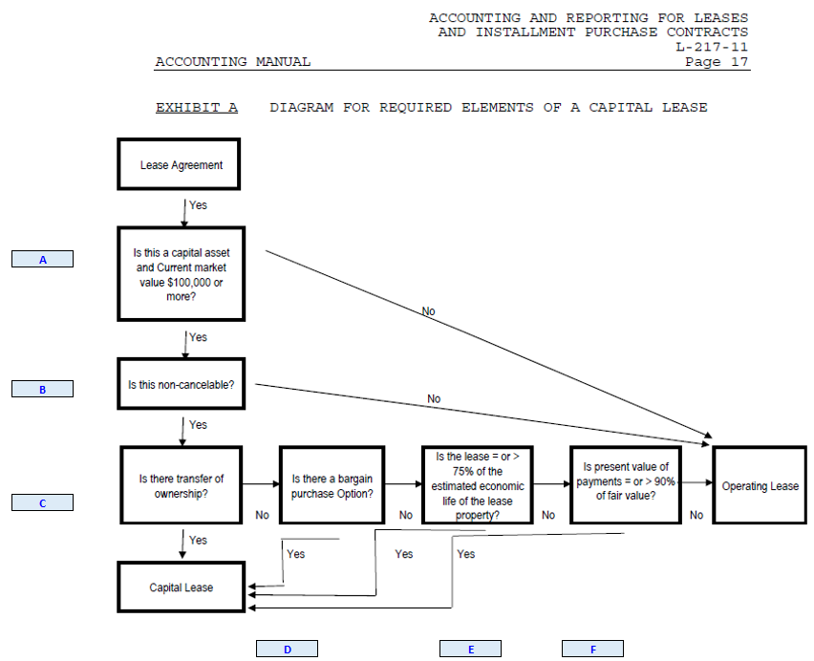
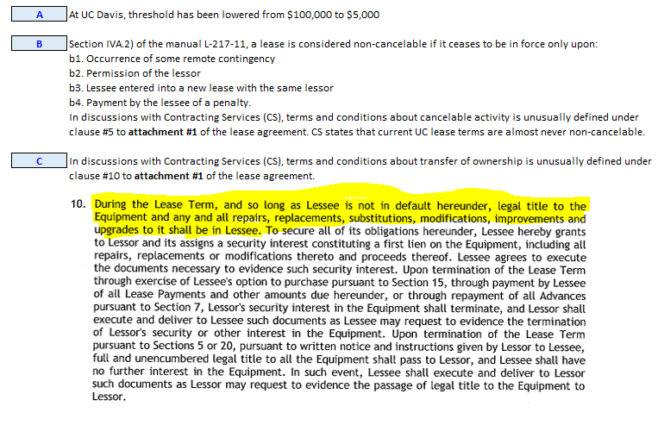
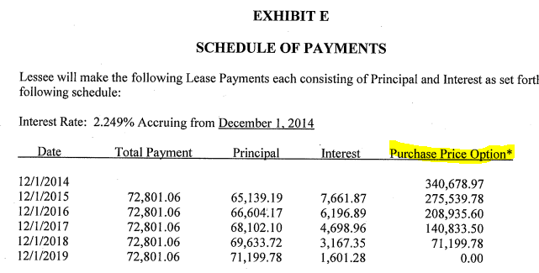
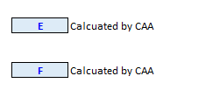
- Recording of lease activity using the appropriate object code:
- Capital Lease
Moveable equipment | Obj 5330 (principal) / 5331 (interest)
Nonmoveable equipment | Obj 5130 (principal) / 5131 (interest)
Noncapital expense | Obj 5601 (principal) / 5602 (interest)
- Operating Lease
Rental of equipment, 1 year or less | Obj 5300
Rental of equipment, more than 1 year | Obj 5321
Rental of space, 1 year or less | Obj 5100
Rental of space, more than 1 year | Obj 5121

References/Link

Governmental/Accounting Standards Board Statements:
- Financial Accounting Standards Board (FASB) Statement No. 13, Accounting for Leases

UCOP Policy
- AM-L217-11- Accounting and Reporting for Leases and Installment Purchases Contracts

